Week 5
Create a TODO application in react with necessary components and deploy it into GitHub.
Aim
To develop a simple TODO application using React, push it to GitHub, and deploy it on GitHub Pages.
Software Requirements
- Node.js (LTS version)
- npm (comes with Node.js)
- Git installed on system
- GitHub account
- Code editor (VS Code preferred)
Procedure
Step 1: Create a React Project
- Open Command Prompt / Terminal.
- Navigate to the folder where you want to create the app.
Example:
cd C:\Users
Create a React project:
npx create-react-app todo-reactapp
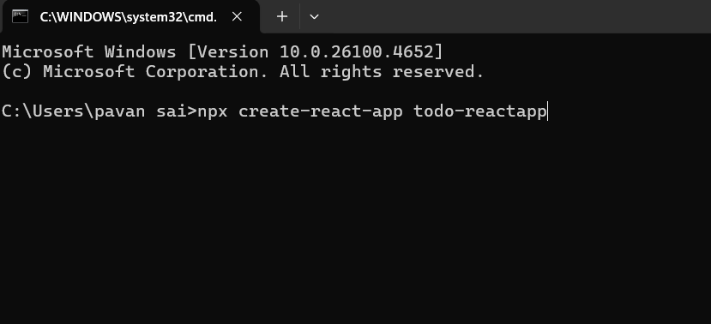

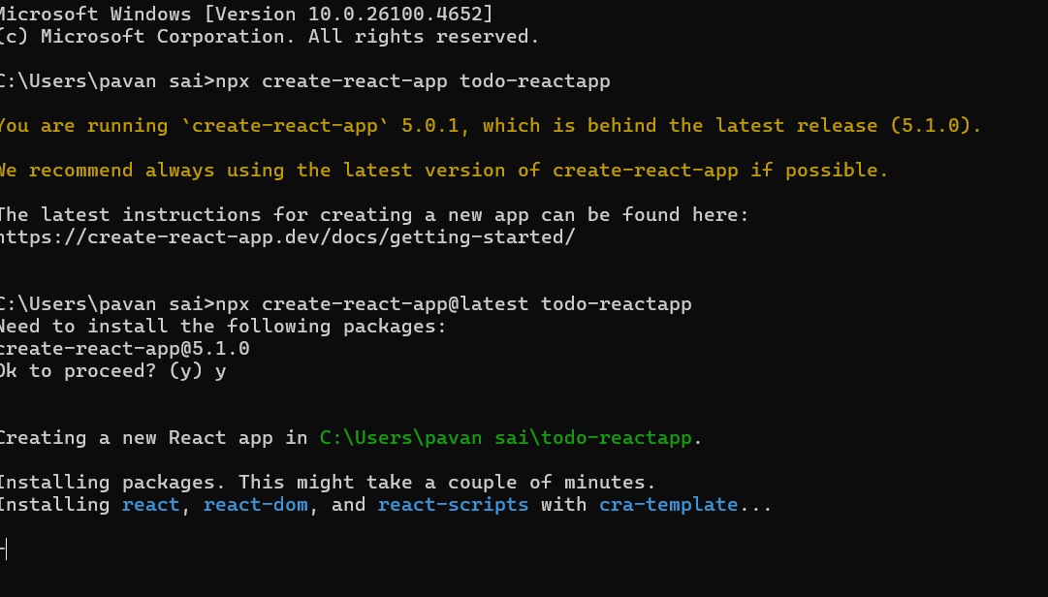
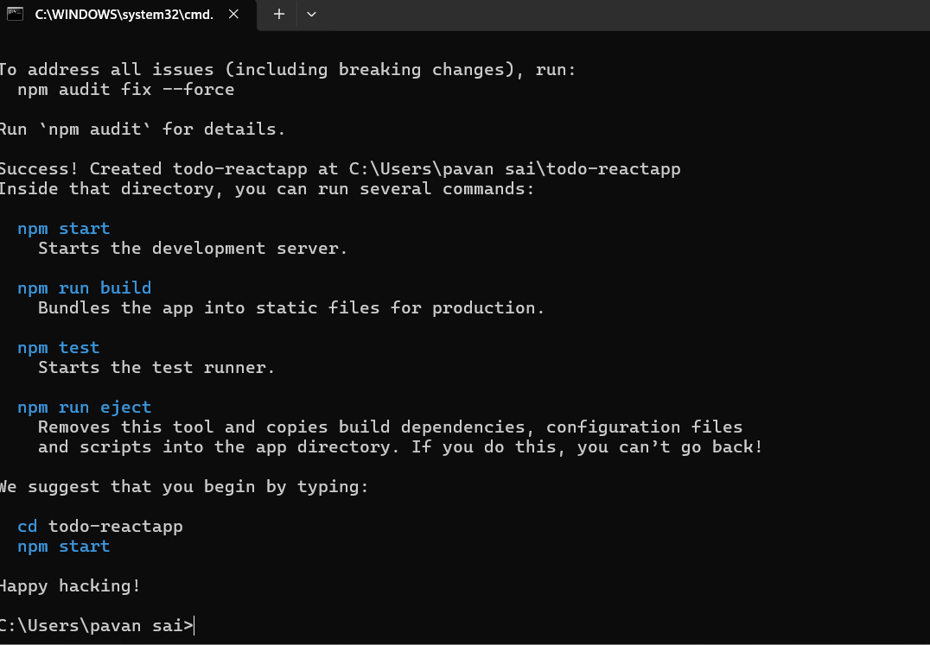
Navigate to project folder:
cd todo-reactapp
Start the development server:
npm start
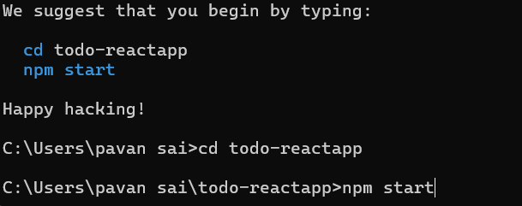

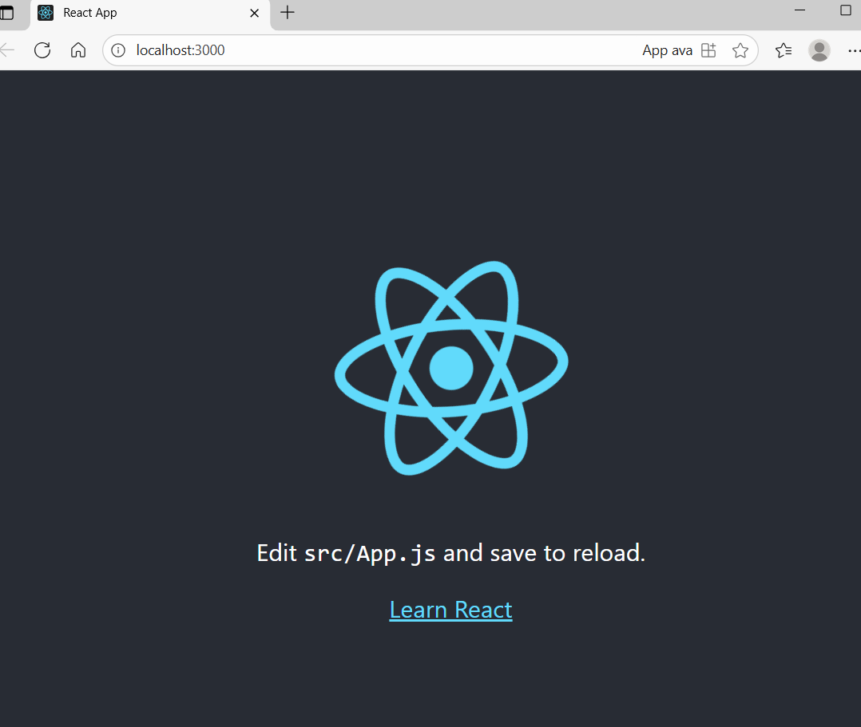

Step 2: Build the todo reactapp
Open project in VS Code:
Open visual studio code
File …> select folder
Select the folder which we are created
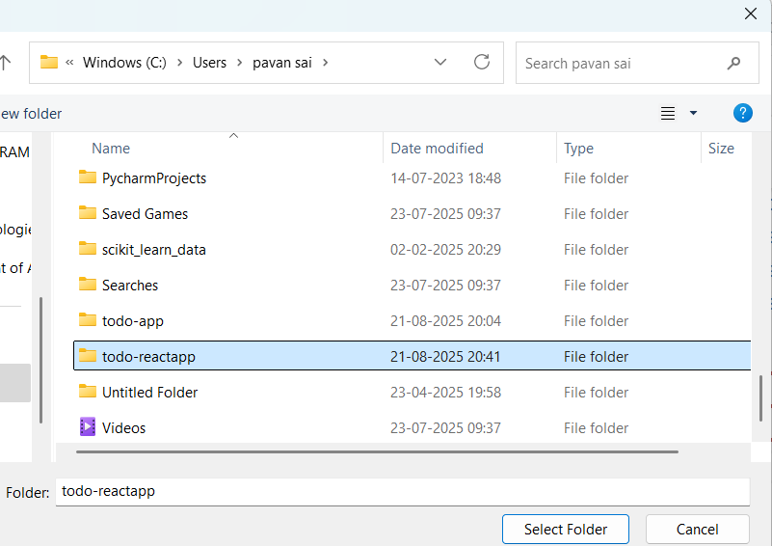

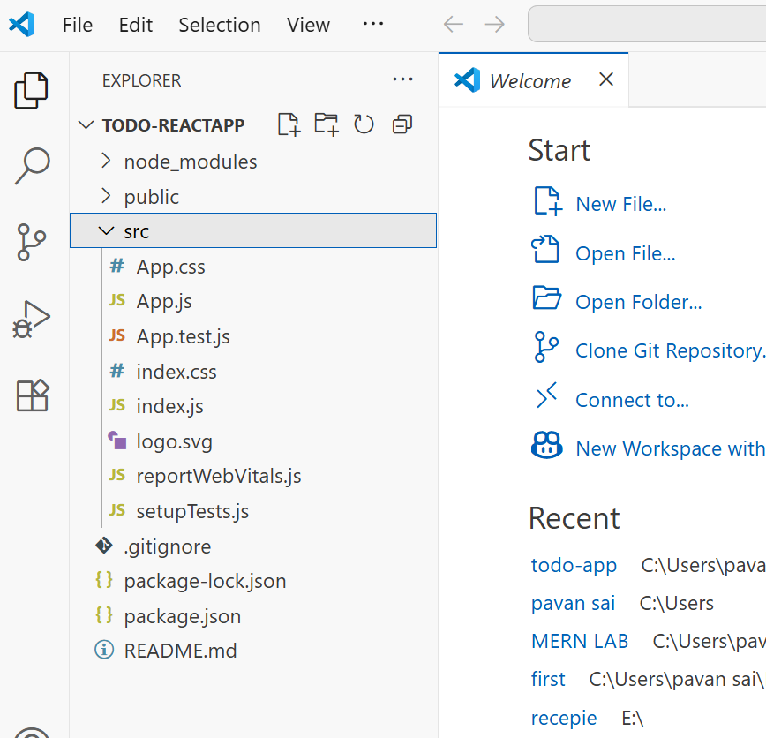

in src/App.js write simple TODO reactapp code:
import React, { useState } from "react";

function App() {
const [task, setTask] = useState("");
const [tasks, setTasks] = useState([]);

const addTask = () => {
if (task.trim() === "") return;
setTasks([...tasks, task]);
setTask("");
};

const deleteTask = (index) => {
const newTasks = tasks.filter((_, i) => i !== index);
setTasks(newTasks);
};

return (
<div style={{ textAlign: "center", marginTop: "50px" }}>
<h1>React TODO App ✅</h1>
<input
type="text"
value={task}
placeholder="Enter a task..."
onChange={(e) => setTask(e.target.value)}
/>
<button onClick={addTask}>Add</button>
<ul>
{tasks.map((t, index) => (
<li key={index}>
{t} <button onClick={() => deleteTask(index)}>❌</button>
</li>
))}
</ul>
</div>
);
}

export default App;

Restart app:

npm start
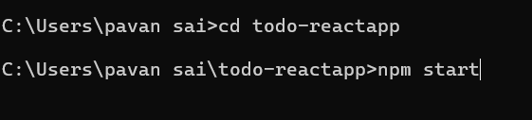

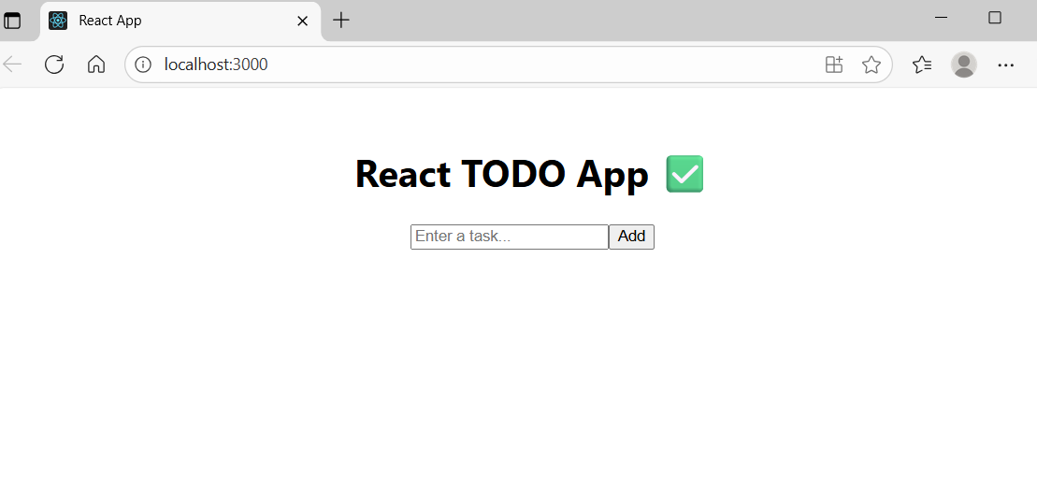

Step 3: Initialize Git & Push to GitHub
Open github login with credentials
Create new repositoty :todo-reactapp
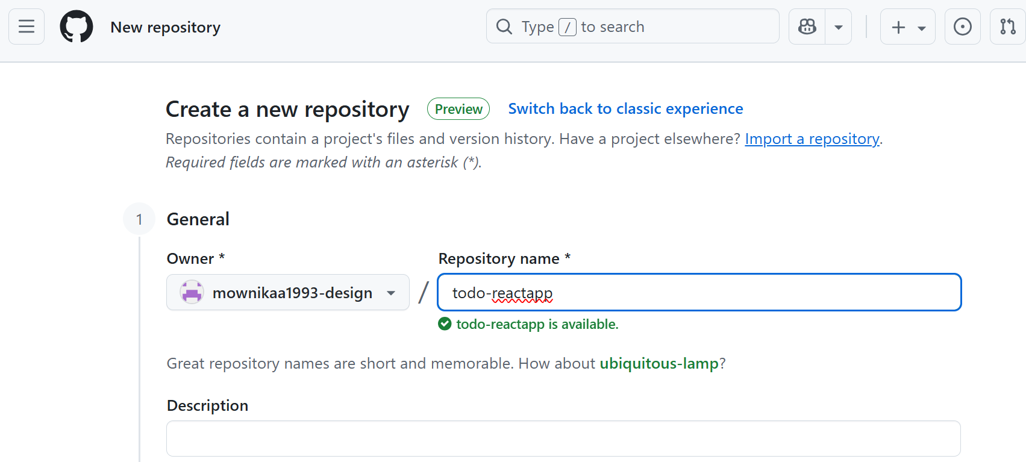

At the end click on create repository

Next Open command prompt
Initialize Git: git init
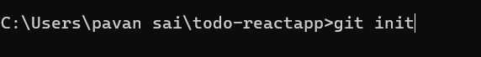

Add files: git add .
Commit changes: git commit -m "Initial commit - React TODO App"

Add remote repo:

git remote add origin
git remote add origin https://github.com/<your-username>/todo-reactapp.git

Rename branch & push:
git branch -M main
git push -u origin main
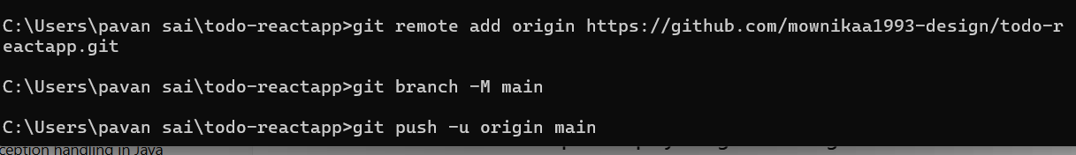

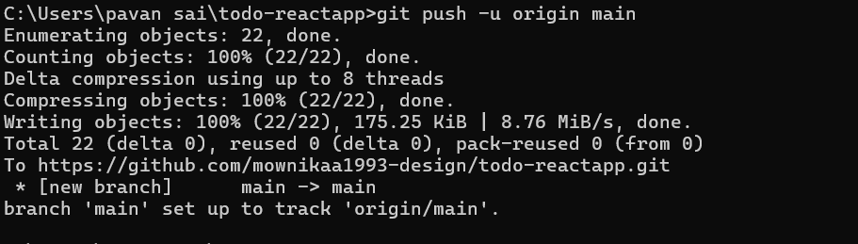
Check in github

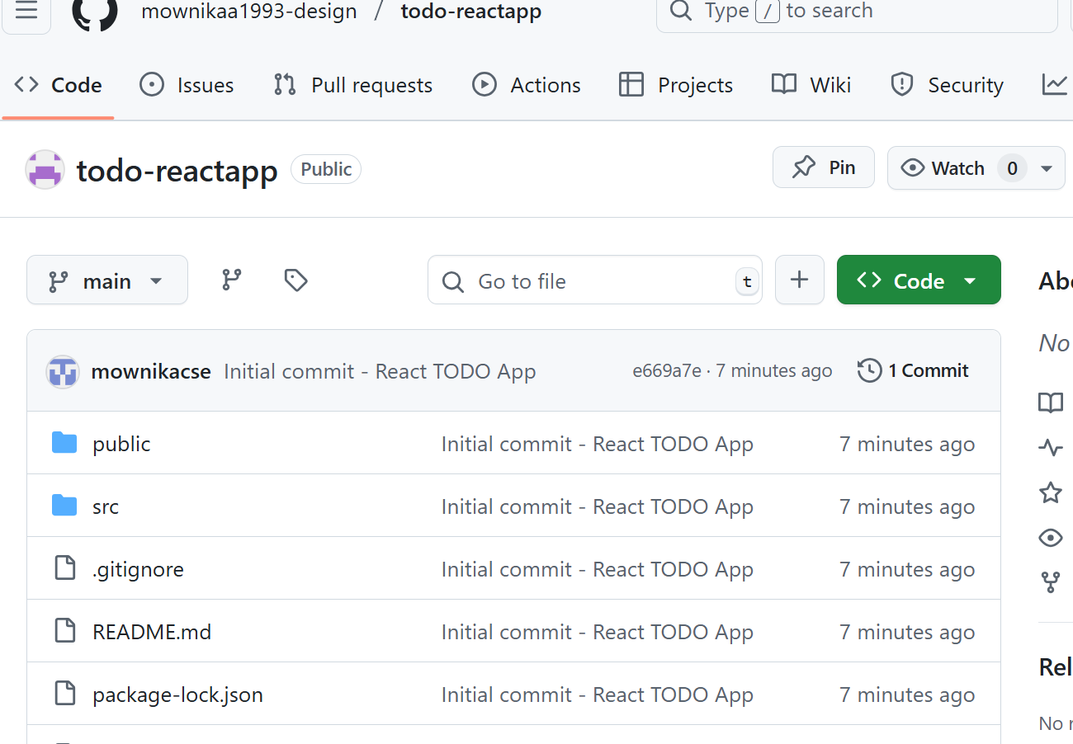
Deploy with GitHub Pages
Install gh-pages package:
npm install gh-pages --save-dev
Edit package.json in VSCode:
Add "homepage" field at top:
"homepage": "https://<your-username>.github.io/todo-reactapp",
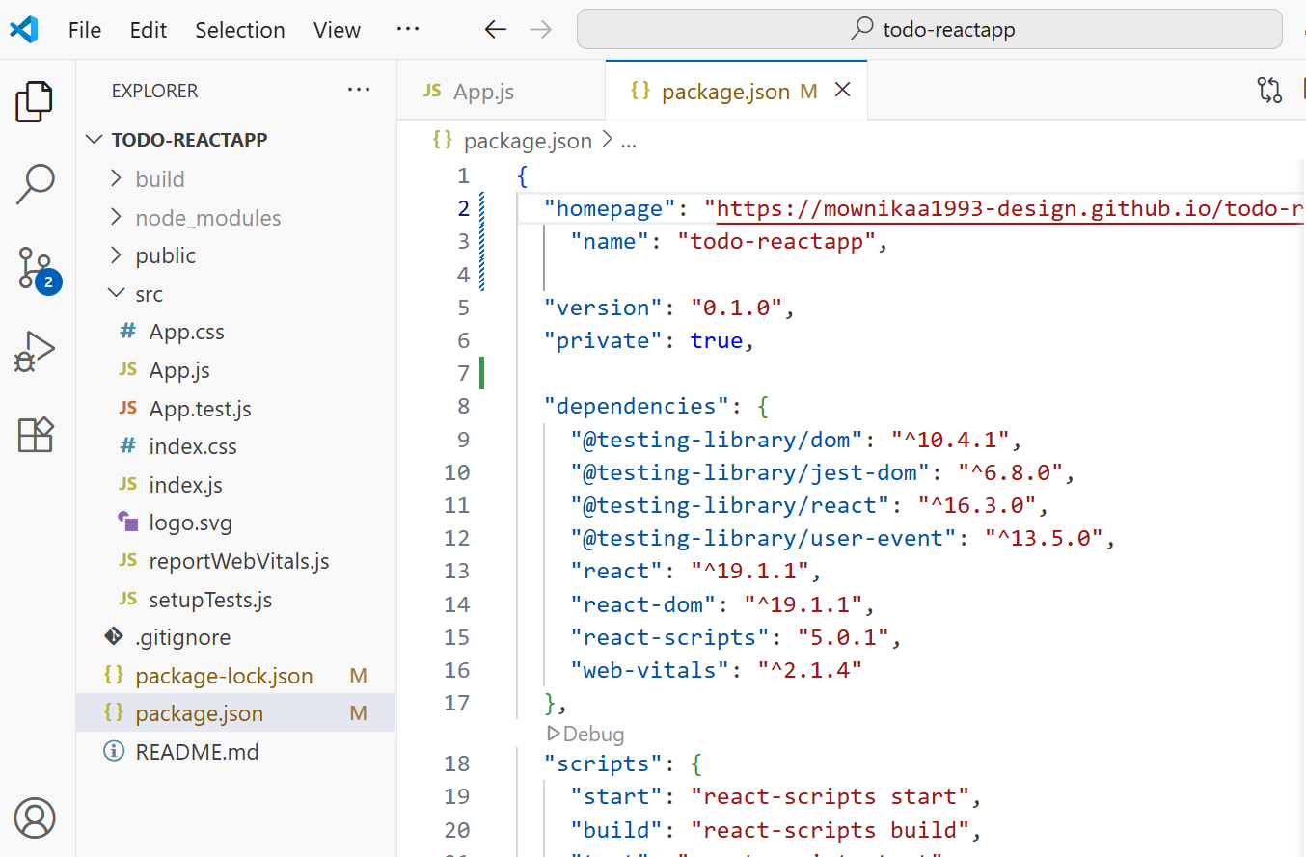
In "scripts" section, add:
"predeploy": "npm run build",
"deploy": "gh-pages -d build"
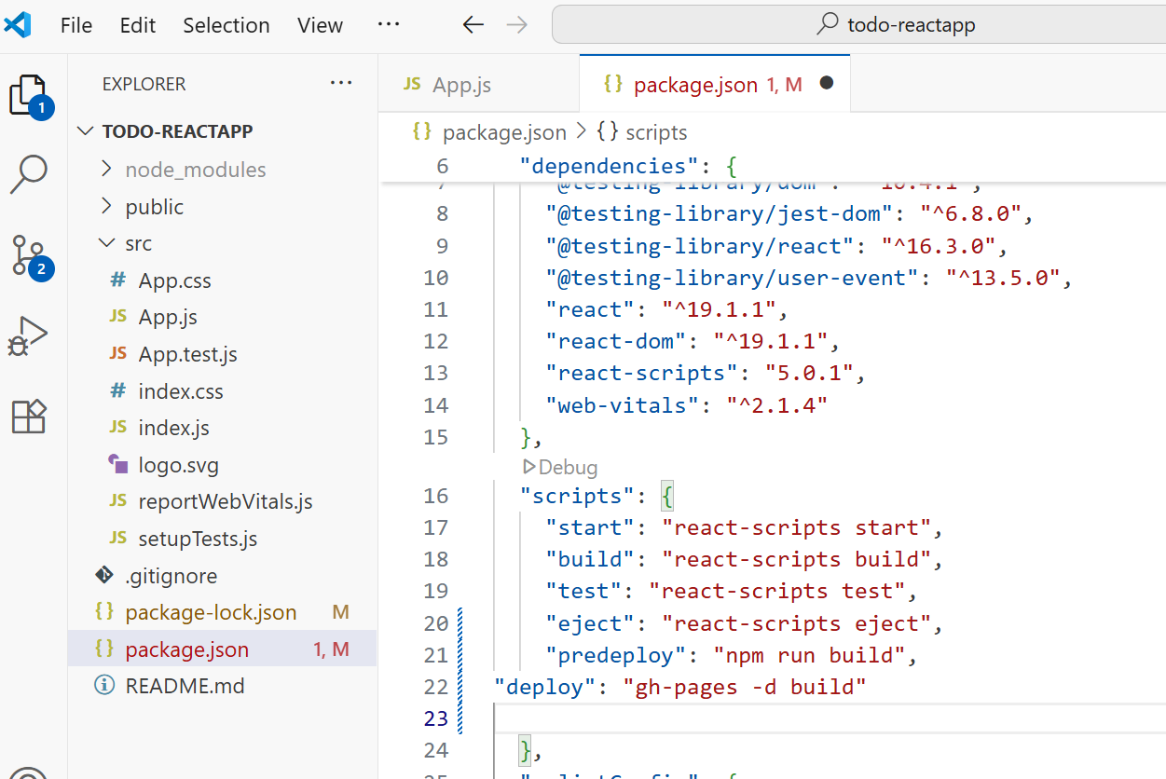
Deploy app:
npm run deploy
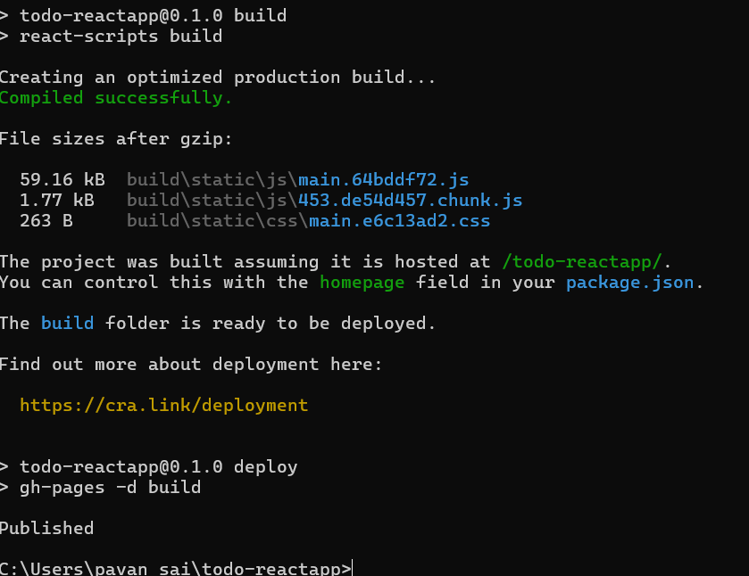

Go to GitHub → Settings → Pages → Branch gh-pages.

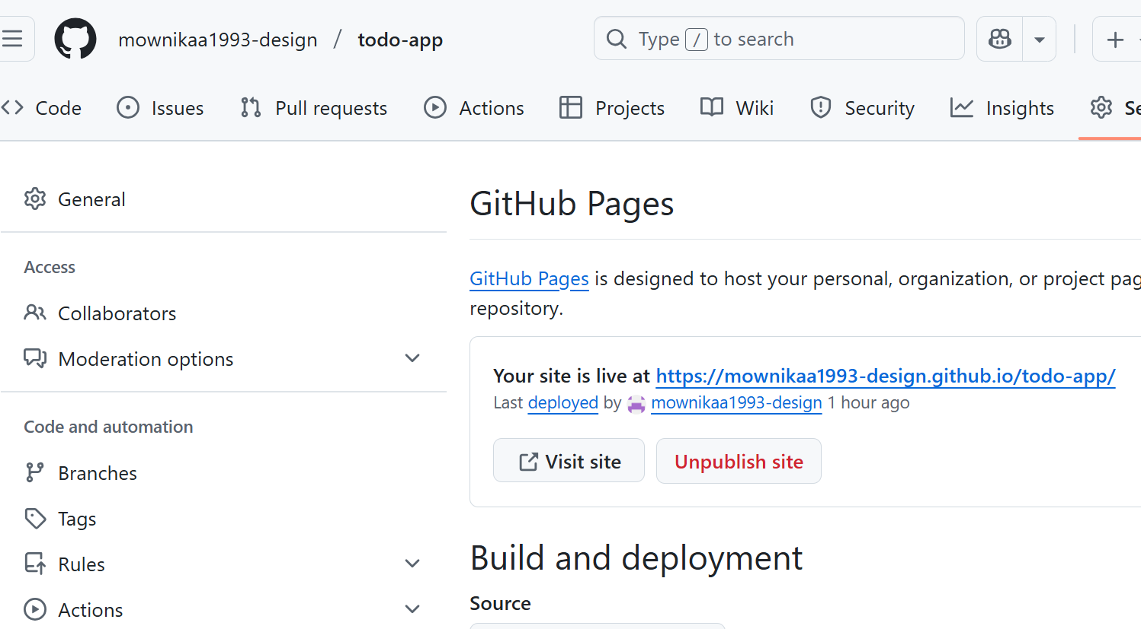

GIT COMMANDS
- git init → Start Git tracking in local folder.
- git add . → Stage all files.
- git commit -m "msg" → Save a snapshot.
- git remote add origin <URL> → Connect local repo to GitHub.
- git branch -M main → Rename branch to main.
- git push -u origin main → Upload code to GitHub.

VIVA Questions
- What is React?
- What is the purpose of npx create-react-app?
- What is the difference between npm start and npm run build?
- What is the role of useState in React?
- What is GitHub Pages?
- What is the purpose of the gh-pages package?
- Why do we add the "homepage" field in package.json?
- What is the difference between git commit and git push?
- What are the steps to deploy a React app on GitHub Pages?
- What are the advantages of using GitHub Pages for deployment?

Understanding the code
import React, { useState } from "react";
- Imports React and the useState hook.
- useState lets us create and manage state (data that changes dynamically) inside a functional component.
function App() {
- Defines the main functional component App.
- This is the root component of our React application.
const [task, setTask] = useState("");
const [tasks, setTasks] = useState([]);
- task → a string that stores the current input (what the user types).
- tasks → an array that stores all tasks added by the user.
- setTask and setTasks are functions used to update these states.

const addTask = () => {
if (task.trim() === "") return;
setTasks([...tasks, task]);
setTask("");
};

- addTask function runs when the user clicks Add.
- Checks if input is empty → if yes, it does nothing.
- If not empty → adds the current task to the tasks array (...tasks means keep old tasks, add new one).
- Clears the input field (setTask("")).

const deleteTask = (index) => {
const newTasks = tasks.filter((_, i) => i !== index);
setTasks(newTasks);
};

- deleteTask function removes a task at a specific index.
- filter creates a new array without the selected index.
- Updates the tasks state → effectively deletes the task.

JSX (UI part):
- input → textbox bound to task (controlled component). When user types, setTask updates the state.
- button → calls addTask when clicked.
- ul → unordered list that shows all tasks.
- tasks.map(...) → loops through the tasks array and displays each task as a <li>.
- Each task has a ❌ button that calls deleteTask(index) to remove it.
export default App;
- Exports the App component so it can be used in index.js.
- App.js → Contains our main application code (TODO app logic, UI).
- index.js → Entry point that loads <App /> into the browser.
- Without index.js, our React components would never be displayed in the actual webpage.

